PAHARI HOME SOLUTION PVT.LTD.

**Assignment**

**HTML & CSS (Answer)**

1.HTML stand for Hyper Text Markup Language.

2.The purpose if <head> tag use in html is set a head section of an HTML document.

3.To create a hyperlink in HTML we should use <a> tag.

4.A semantic element clearly describes its meaning to both the browser and the developer. Example: <table>, <from>, <footer>, <nav>…etc.

5.Margin is the space around an element and Padding is the space between the element and the content inside it.

6. If I have a div and his class name “main” so write .main{margin:auto} this CSS center the the div. we can do this by use flex box. Like this body{ display:flex; justify-content: center;} the div should be inside the <body> tag.

7.In CSS media query used to make our website responsive for each and every devise.

8. The CSS box model is a component that contains multiple properties including borders, margin, padding. It is used to develop the design and structure of a web page.

9.If we want to use custom Font style we use “font-family” properties. Example: font-family: 'Segoe UI', sans-serif;

10.z-Index is a CSS property that defines the order of overlapping HTML elements.

**JavaScript (Answer)**

11.In JavaScript let and const declarations are block-scoped and var declarations are either globally scoped or function-scoped.

12.DOM stand for Document Object model. DOM is a programming interface for web document. It represents the page so that programs can change the document structure, style, and content.

13.If we want to create an event listener first we have select the particular element by use this properties: “getElementById”,“getElementsByClassName”, “querySelector”…etc. Then we use this syntax: targerelement.addEventListener(type, listener).

14.Asynchronous is a non-blocking architecture, so the execution of one task isn't dependent on another. Tasks can run simultaneously. Synchronous is a blocking architecture, so the execution of each operation depends on completing the one before it. Each task requires an answer before moving on to the next iteration.

15.A Promise is an object representing the eventual completion or failure of an asynchronous operation.

Promise Syntax:

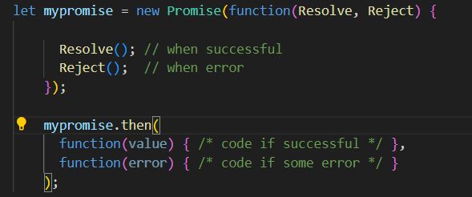

16.In JavaScript, the “this” keyword refers to the object that is currently executing or calling the function. It is a way to access and manipulate the properties and methods of the object that called the function. Example:

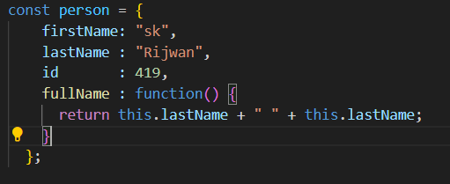

17.In JavaScript the == operator does the type conversion of the operands before comparison of values, whereas the === operator compares the values and the data types of the operands.

18.In JavaScript, map() is a method of the Array object. It creates a new array by calling a function on every element of the original array and storing the results in a new array. map() returns the new array, and the original array is unchanged.

**PHP & PYTHON (Flask) (Answer)**

19.In PHP, a variable starts with the $ sign. Syntax :

$x = 5;

$y = "John";

20.Session in PHP is a way of temporarily storing and making data accessible across all the website pages. It will create a temporary file that stores various session variables and their values.

21. Include and require functions in PHP that are used to import external files/modules into our code and evaluate them at the place where they have been imported.

22.App Routing means mapping the URLs to a specific function that will handle the logic for that URL. Modern web frameworks use more meaningful URLs to help users remember the URLs and make navigation simpler.

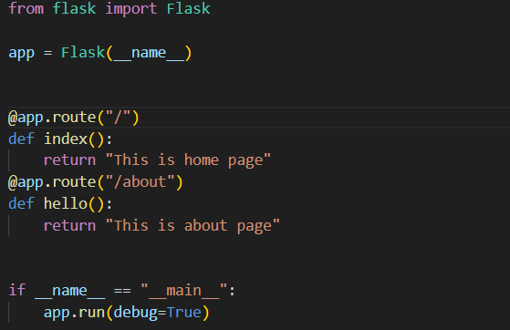

23. To create a virtual environment for a Flask project in Python follow the commend:

//first install the virtual environment package

// Enter your virtual environment name and create it

24. Jinja2 is one of the most used Web template engines for Python. This Web template engine is a fast, expressive, extensible templating engine. Jinja2 extensively helps to write Python code within the HTML file.

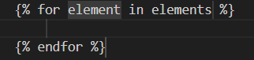Example: for loop in jinja2

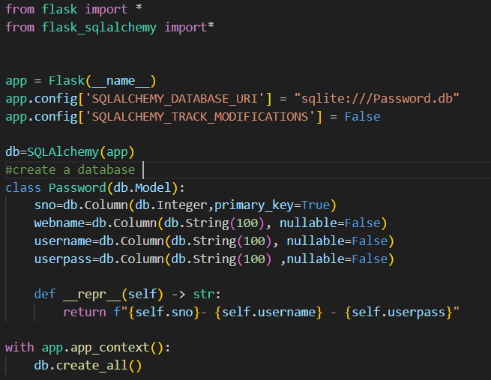25.In your Flask project if you want to interact with database you should use Flask-SQLAlchemy extension. And follow the code:

//In this code a database create name “password.db” in this database store all data that come from flask web app.   
// <https://github.com/skrijwan100/Password-manager> in this project i connect flask app with data base.